> how can I test that the SEO and enhancements work

● Here's how to test everything, from local checks you can do right now to post-deployment verification:

Immediate Local Tests (do these now)

1. Validate structured data (JSON-LD):
Open your browser to http://localhost:3000, view page source (Ctrl+U), copy the entire HTML, then paste it into:
- Google Rich Results Test: https://search.google.com/test/rich-results
- Schema.org Validator: https://validator.schema.org

This will confirm all 7 JSON-LD blocks parse correctly and show which rich results you qualify for (FAQ dropdowns, local business, knowledge panel).

2. Check meta tags in browser:
http://localhost:3000
Press F12 → Elements → search for <title> and verify it starts with "Cybersecurity Consulting Firm". Check <meta name="description" is 400+ chars.

3. Test robots.txt and sitemap:
http://localhost:3000/robots.txt
http://localhost:3000/sitemap.xml
Verify robots has Googlebot/Bingbot sections and sitemap has 13 URLs.

4. Test the noscript fallback:
In Chrome: F12 → Settings (gear icon) → Debugger → check "Disable JavaScript" → reload the page. You should see the keyword-rich fallback content. Re-enable JS when done.

5. Check response headers (restart server first for caching):
! curl -sI http://localhost:3000/ | grep -iE "(cache|link)"

Free Online SEO Audit Tools

After deploying to your live domain (security.laurelshield.com), run these:
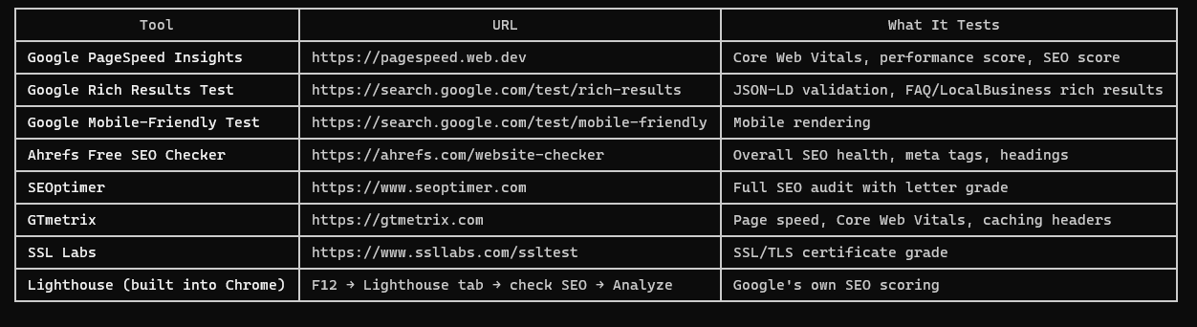

Chrome Lighthouse (do this now, locally)

1. Open http://localhost:3000 in Chrome
2. Press F12 → click Lighthouse tab
3. Check: Performance, Accessibility, Best Practices, SEO
4. Click Analyze page load
5. Target: SEO score 90+, Performance 80+

Post-Deployment (after live on Render)

Google Search Console (critical):
1. Go to https://search.google.com/search-console
2. Add property: https://security.laurelshield.com
3. Verify ownership (HTML tag or DNS method)
4. Submit sitemap: Sitemaps → Add → https://security.laurelshield.com/sitemap.xml
5. URL Inspection → paste homepage → click "Request Indexing"
6. Check back in 2-7 days for indexing status

Bing Webmaster Tools:
1. Go to https://www.bing.com/webmasters
2. Add site and submit sitemap
3. Bing often imports from Google Search Console automatically

Test social sharing previews:
- Facebook: https://developers.facebook.com/tools/debug/ — paste your URL to see OG preview
- Twitter: https://cards-dev.twitter.com/validator — paste URL to see card preview
- LinkedIn: Share the URL in a post draft to preview the card

Monitor Rankings Over Time

After indexing (1-4 weeks), search for these terms and track your position:
- "Laurel Shield" (branded — should be #1 immediately)
- cybersecurity consulting Calgary
- cybersecurity consulting Philadelphia
- penetration testing company
- HIPAA compliance consulting
- AI security consulting
- SOC 2 audit company

Free rank tracking: https://www.google.com/search — search in incognito mode from different locations, or use https://ahrefs.com/rank-checker

Realistic expectation: Ranking #1 globally for just "cybersecurity" competes with Wikipedia, CISA.gov, and billion-dollar companies. The SEO we implemented maximizes your chances for long-tail keywords like
"cybersecurity consulting firm Calgary", "HIPAA compliance consulting", "AI security assessment company", "penetration testing services Philadelphia" — these are the terms that actually drive qualified
leads.

───────────────────────────────────────────────────────────────────────────────────────────────────────────────────────────────────────────────────────────────────────────────── laurel-shield-logo-redesign ──
>

